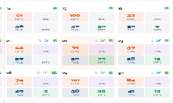
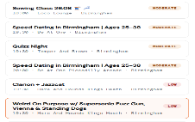
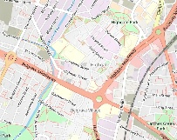



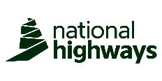




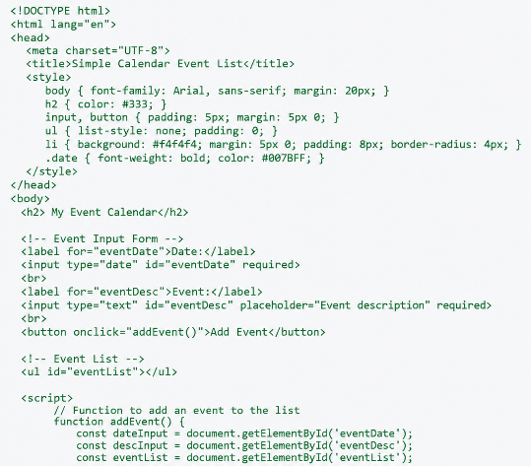

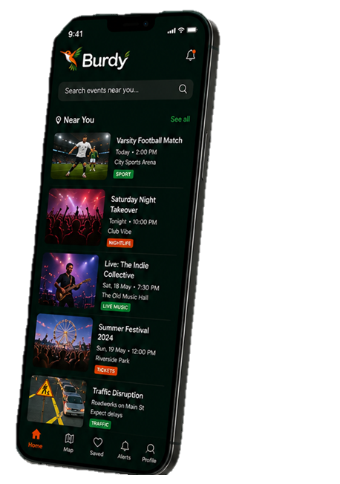


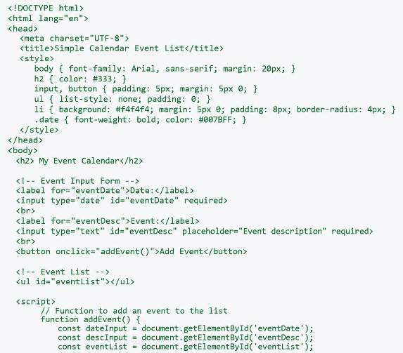
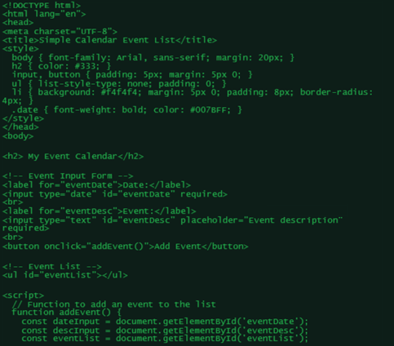
GET THE BURDY ADVANTAGE
Use live customer data the way that works for you along with and trending socials to make your business smarter with real market insight.
IN PARTNERSHIP WITH
ENVIRONMENTAL IMPACT
DEMAND FORECASTING
PRODUCT IMPACT
HISTORICAL COMPARISON
CROSS MARKET PERFROMANCE
ALERTS AND NOTIFICATIONS
SMARTER ROTA PLANNING
Burdy gives your business the real time edge.
INCREASE SALES
Know when demand is high so you can stock smarter, promote better and sell more
OPTIMISE ROTAS
Build smarter rotas with predictive footfall and event insights
UNDERSTAND YOUR MARKET
Insights on footfall, spend potential and customer behaviour in your area
STAY AHEAD OF EVENTS
See what’s happening near you and plan with confidence.
TARGETED PROMOTIONS
Reach the right audience at the right time with event driven campaigns
All the events, footfall drivers and local insights you need – in one powerful platform
Know what’s happening. Understand market demand. Optimise your rota. Maximise sales.
DEEPER INSIGHT.
MORE SALES.
DATA. DELIVERED.

REAL TIME MONITORING
BETTER ROTAS.
LIVE INSIGHTS AND UPDATES
100+ CATEGORIES COVERED
50,000+ VENUES AND BUSINESSES
1,000,000+ EVENTS TRACKED
KNOW MORE. PLAN BETTER. SELL MORE

